13주차 실습과제

20135151 이갑성

1번

.data

ask: .asciiz "Type a character string (<50 chars long): "

bye: .asciiz "Press enter to exit..."

len: .word 50

inputStr: .space 50

copyStr: .space 50

.text

.globl main

main:

li $v0, 4 # system code 4: print a string

la $a0, ask # '$a0' will point out 'ask'

syscall

la $a0, inputStr # '$a0' will point out 'inputStr'

lw $a1, len # Load word-0 from 'len' into '$a1'

li $v0, 8 # system code 8: read a string

syscall

li $t2, 96 # '$t2' will store the value 97 (97 == ASCII 'a')

li $t3, 123 # '$t3' will store the value 122(122 == ASCII 'z')

add $t0, $0, 0 # '$t0' will store the value 0 ('$t0' is the index)

loop:

lb $t1, inputStr($t0) # Load byte-$t0 from 'inputStr' into '$t1'

# Fetch a character from 'inputStr' into '$t1'

ble $t1, $t2, skip # if($t1 < $t2) then go to the label 'skip'

bge $t1, $t3, skip # if($t1 > $t3) then go to the label 'skip'

addi $t1, $t1, -32 # $t1 <- $tt1 - 32

# Cover to upper case

#the gap between lower case and upper case is 32

skip:

sb $t1, copyStr($t0) # Store a byte in '$t1' into byte-$t0 from 'copyStr'

addi $t0, $t0, 1 # $t0 <- $t0 + 1(Increase index)

bne $t1, $0, loop # if($t1 != 0) then go to the label 'loop'

finish:

li $v0, 4 # system code 4: print a string

la $a0, copyStr # '$a0' will point out 'copyStr'

syscall

li $v0, 4 # system code 4: print a string

la $a0, bye # '$a0' will point out 'bye'

syscall

li $v0, 10 # exit program

syscall

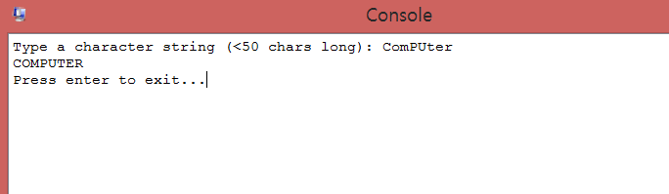

2번

.data

result: .space 32

.byte 0

ask: .asciiz "Enter decimal number: "

ansBin: .asciiz "Binary is: "

ansStr: .asciiz "\nBinary string: "

space: .asciiz " "

.text

.globl main

main:

li $v0, 4 # system code 4: print a string

la $a0, ask # '$a0' will point out 'ask'

syscall

li $v0, 5 # system code 5: read an integer value

syscall # READ

move $t2, $v0 # $t2 <- $v0

li $v0, 4 # system code 4: print a string

la $a0, ansBin # '$a0' will point out 'ansBin'

syscall

li $t4, 4 # '$t4' will store the value 4 for a binary number

li $t0, 32 # We will device 32-digit into 8 groups consist of 4-digit

la $t3, result # '$t0' will store the value 32 for a binary string

# Because we will print a binary number which consist of 32-digit

# '$t3' will point out 'result'

loop:

rol $t2, $t2, 1 # $t2 <- $t2 << 1

# ROL(: Rotate left) is diffenet with 'Shift instuctions'

# After ROL, the leftmost number will be located at the rightmost place

# Start from the leftmost number

andi $t1, $t2, 1 # $t1 <- $t2 AND 1

# Print blank after 4-digit

div $t0, $t4 # $t0 / $t4

mfhi $t5 # The remainder will move to '$t5' register

bnez $t5, print_binary # if ($t5 != 0) then go to the label 'print_binary'

li $v0, 4 # system code 4: print a string

la $a0, space # '$a0' will point out 'sapce'

syscall

print_binary:

li $v0, 1 # system code 1: print an integer value

move $a0, $t1 # $a0 <- $t1 for a binary number

# We will directly print a binary digit

syscall

# Store a digit into a string

addi $t1, $t1, 48 # $t1 <- $t1 + 48 (The ASCII code of '0')

sb $t1 0($t3) # Store a byte in '$t1' into byte-0 from '$t3'

addi $t3, $t3, 1 # $t3 <- $t3 + 1 (Increase the index of 'result')

addi $t0, $t0, -1 # $t0 <- $t0 - 1 (Decrease the count)

bnez $t0, loop # if ($t0 != 0) then go to the label 'loop'

li $v0, 4 # system code 4: print a string

la $a0, ansStr # '$a0' will point out 'ansStr'

syscall

li $v0, 4 # system code 4: print a string

la $a0, result # '$a0' will point out 'result'

syscall

li $v0, 10 # system code 10: exit program

syscall

